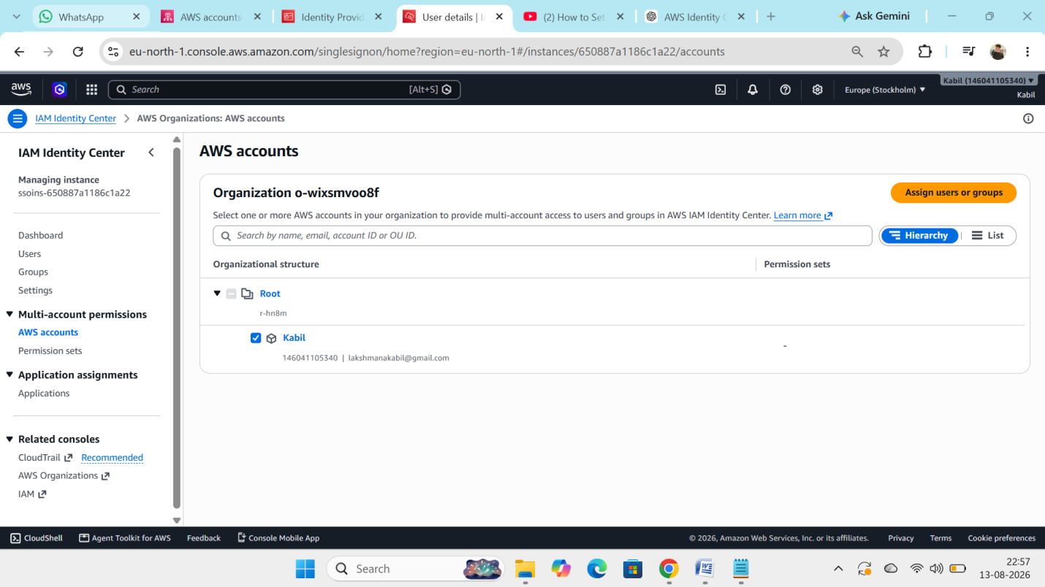
Step 1 : Enable AWS organization
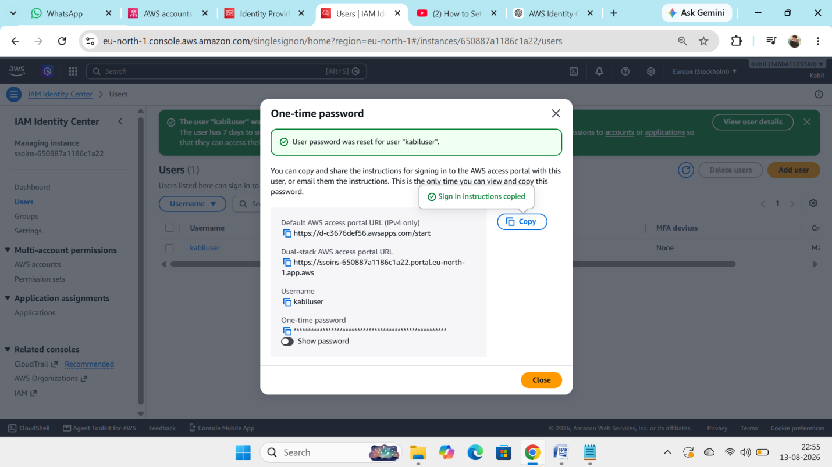
Step 2 : Create an AWS IAM identity center and select Identity center as a Source and create an user it give url and one time password.
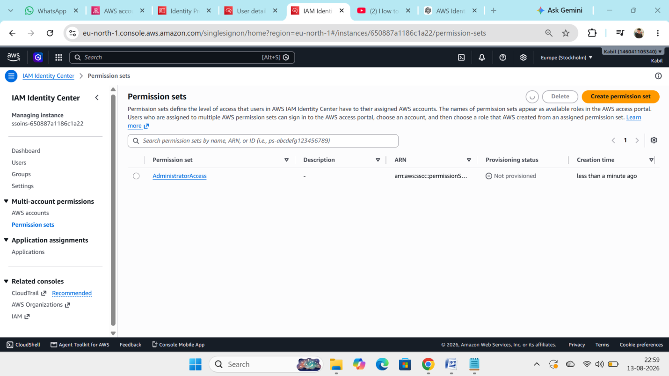Step 3 : Create an Permission set and assigned to particular user(it will create IAM role in inside an account)

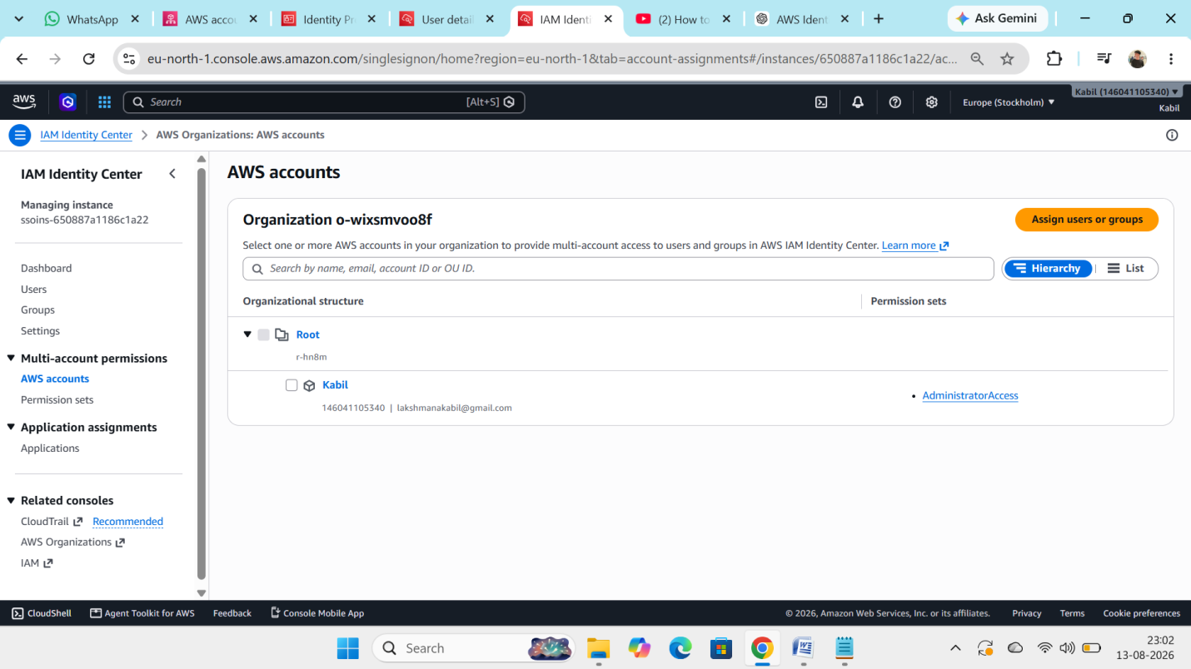
Step 4 : Assigned user to Aws orgainsational account
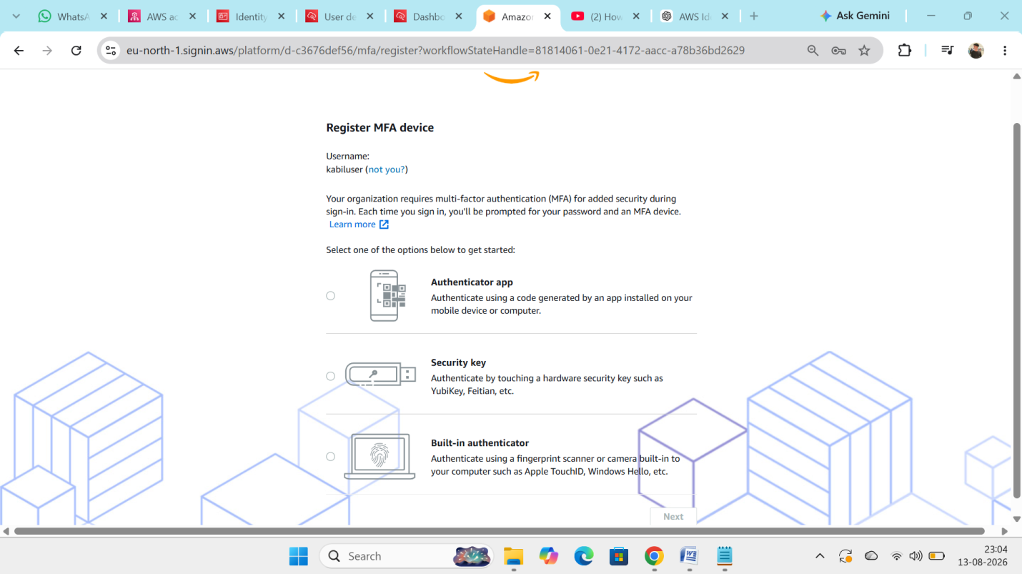
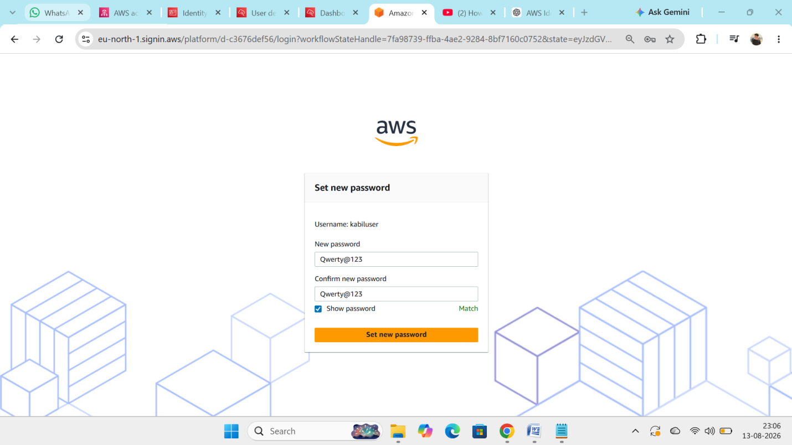

Step 5 : use the identity provider url to login with kabiluser
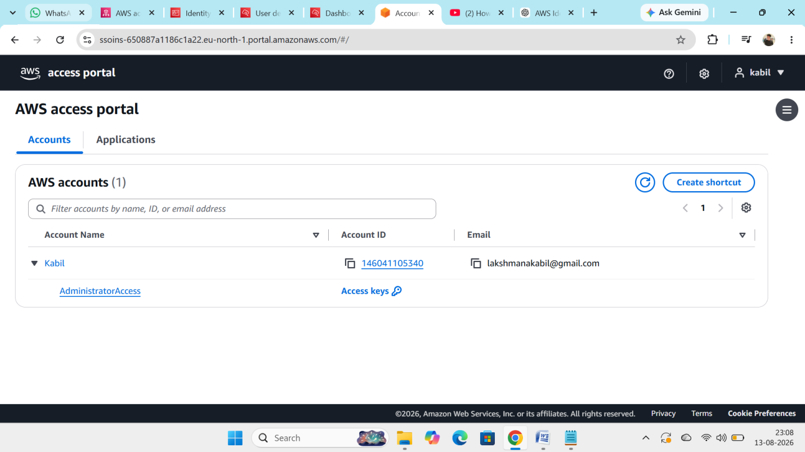
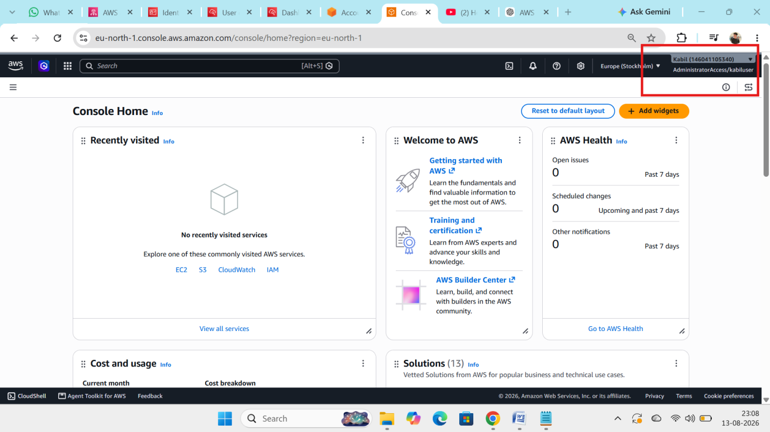

Step 6 : Login as kabiluser with Adminstartor access via SSO.

